Home Page
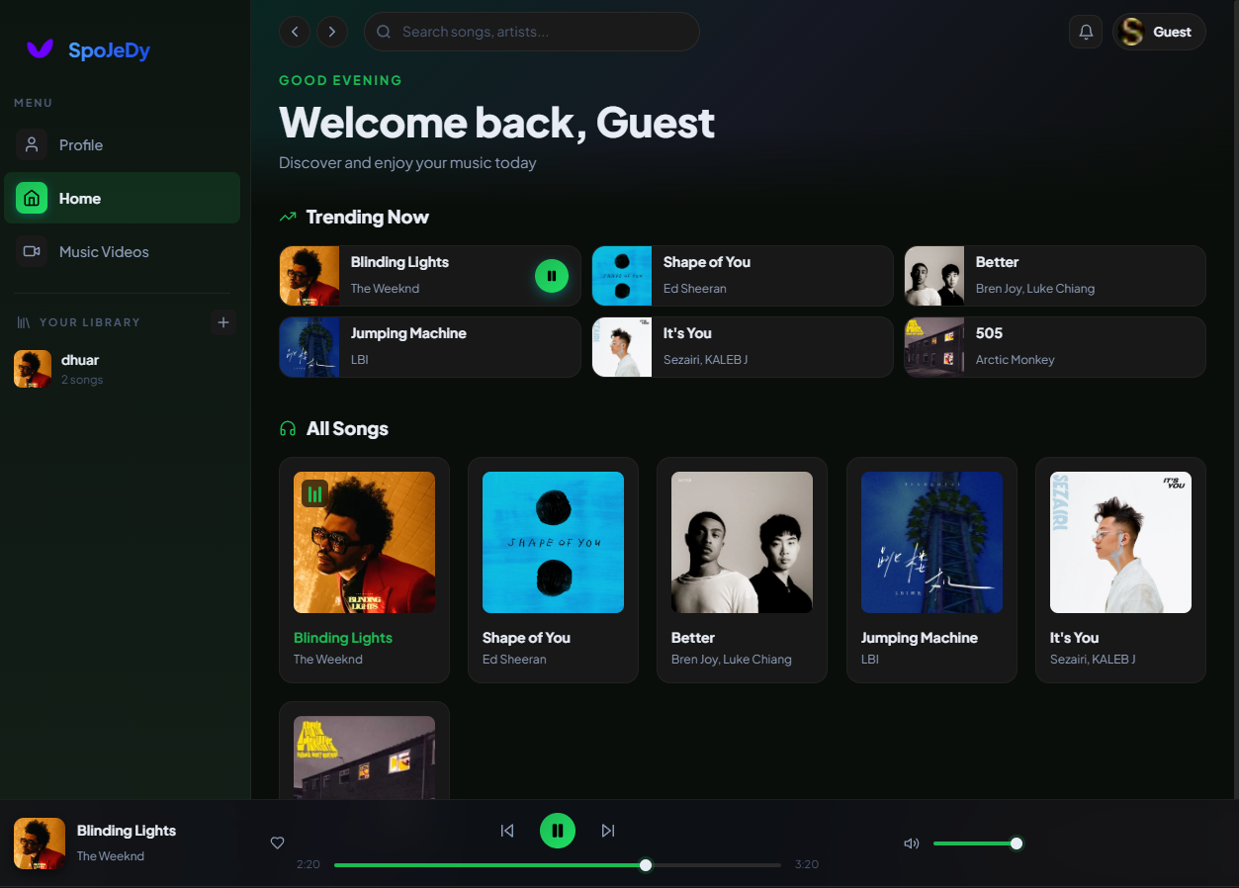
Features:
- Text that greet users
- List of music that have the song title, artist name, and song cover image
- When the song card is clicked, it will direct the user to Song Detail Page
- There’s also search bar to search for the music you want by the name
- The left side is navigation to other page and for making playlist
- There’s also previous button and next button beside search bar

Song Detail Page
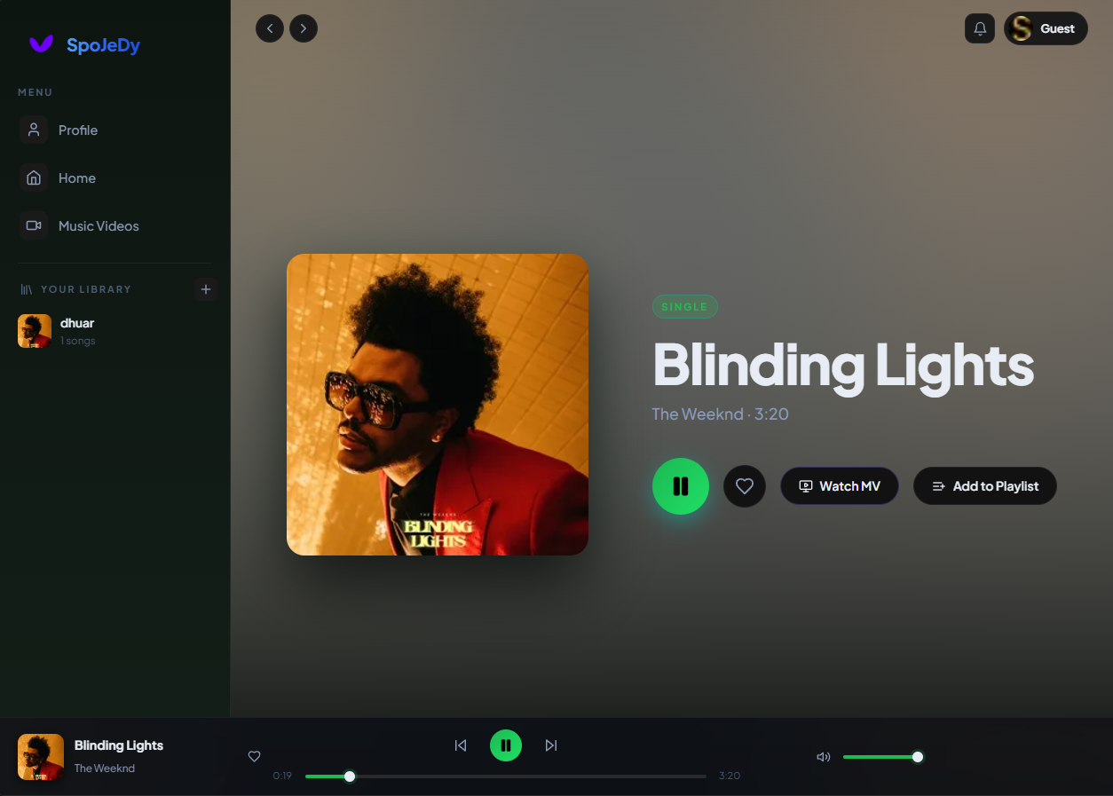
Features:
- When clicked play, the control will appear below (will not be gone even if you go to other page)
- Play/pause song
- Play next and previous song
- Volume control
- Song cover, will be full screen when clicked
- Button to direct to Music Video Detail Page
- Button to add song to playlist you’ve made

Music Video Page
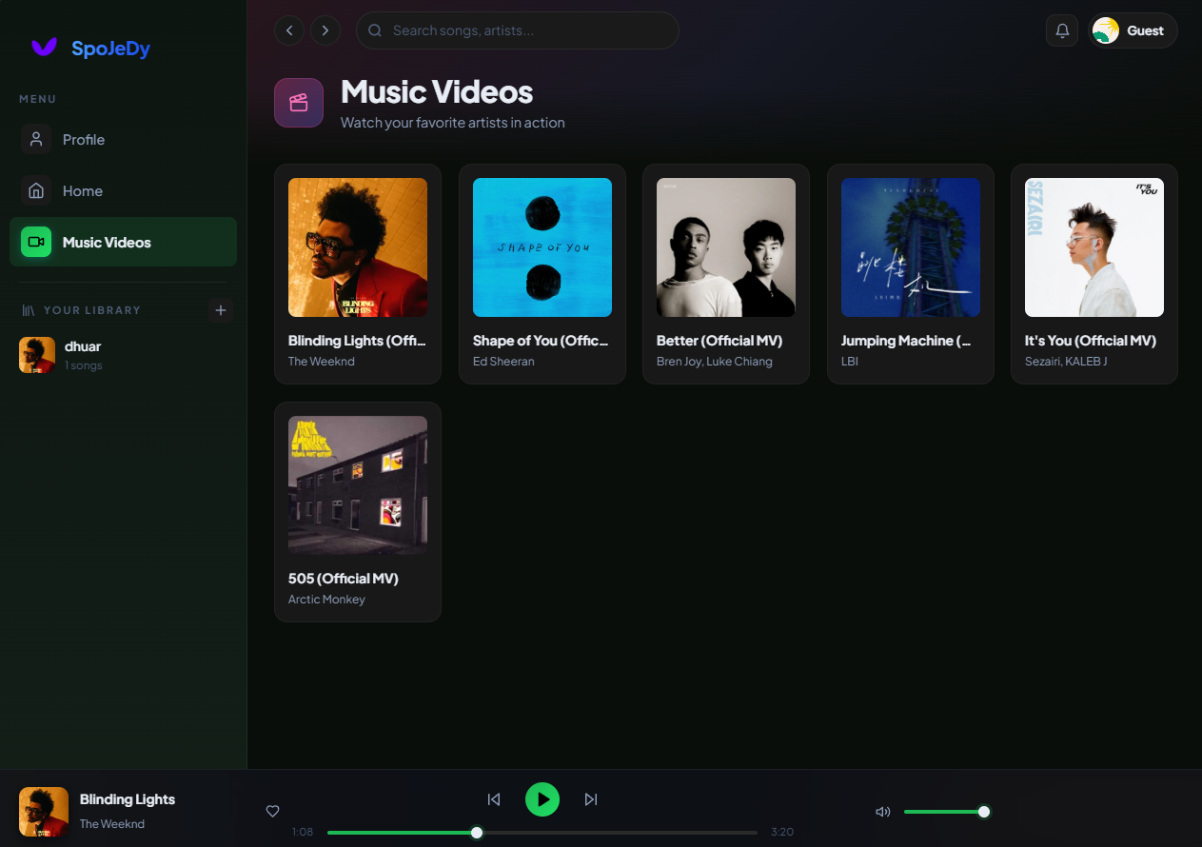
Features:
- List of music video that have the song title, artist name, and song cover image
- When the music video card is clicked, it will direct the user to Song Detail Page
- There’s also search bar to search for the music video you want to watch by the name
- The left side is navigation to other page and for making playlist
- There’s also previous button and next button beside search bar

Music Video Detail Page
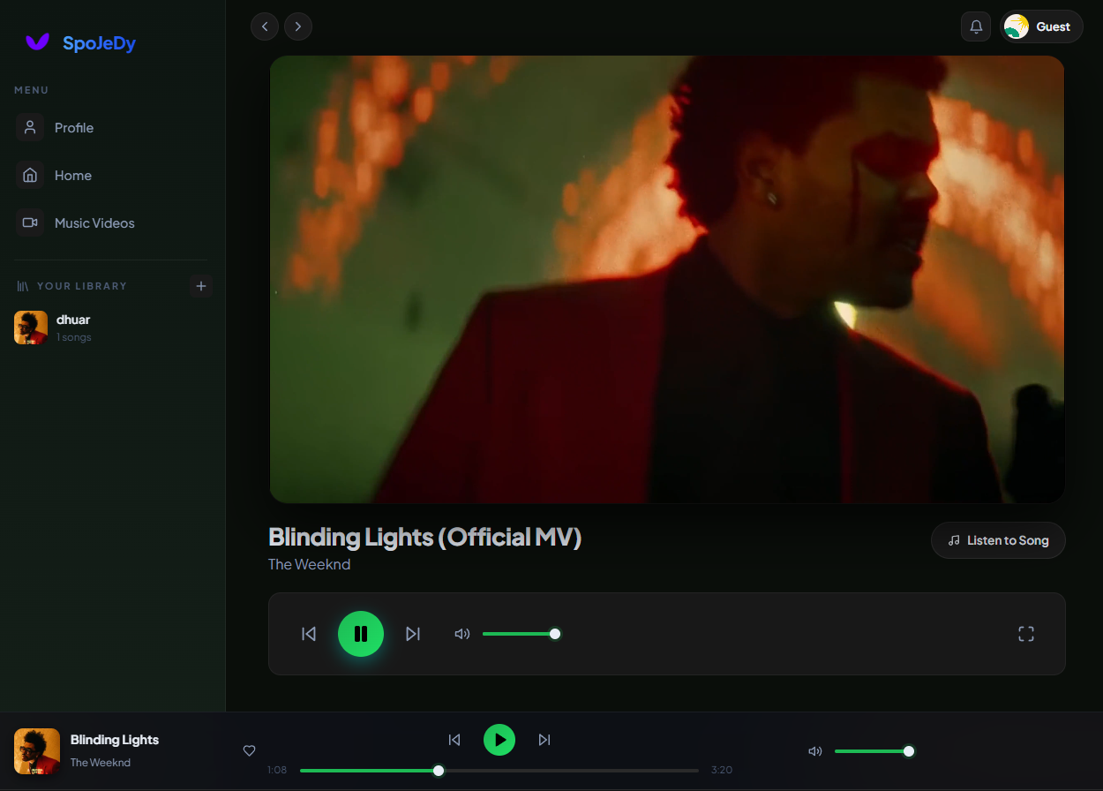
Features:
- Play/pause music video
- Play next and previous music video
- Volume control
- Song cover, will be full screen when clicked
- Button to direct to Music Detail Page
- Full screen button

Profile Page
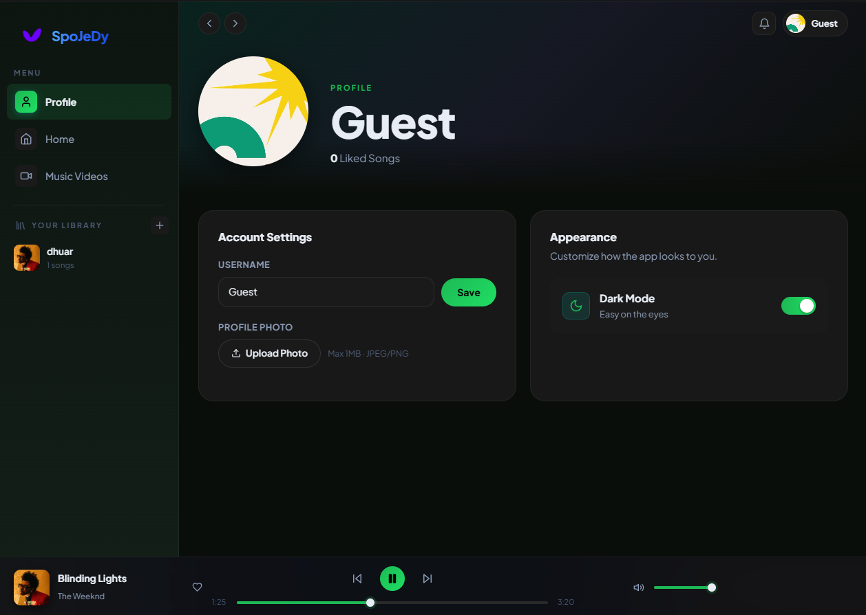

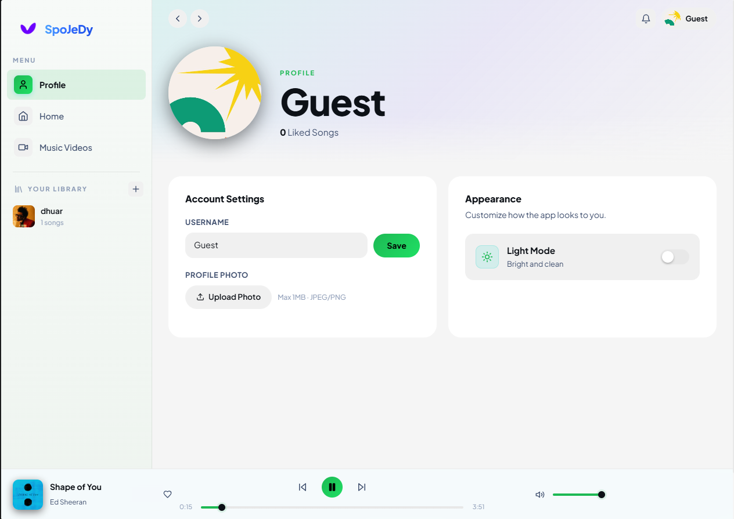

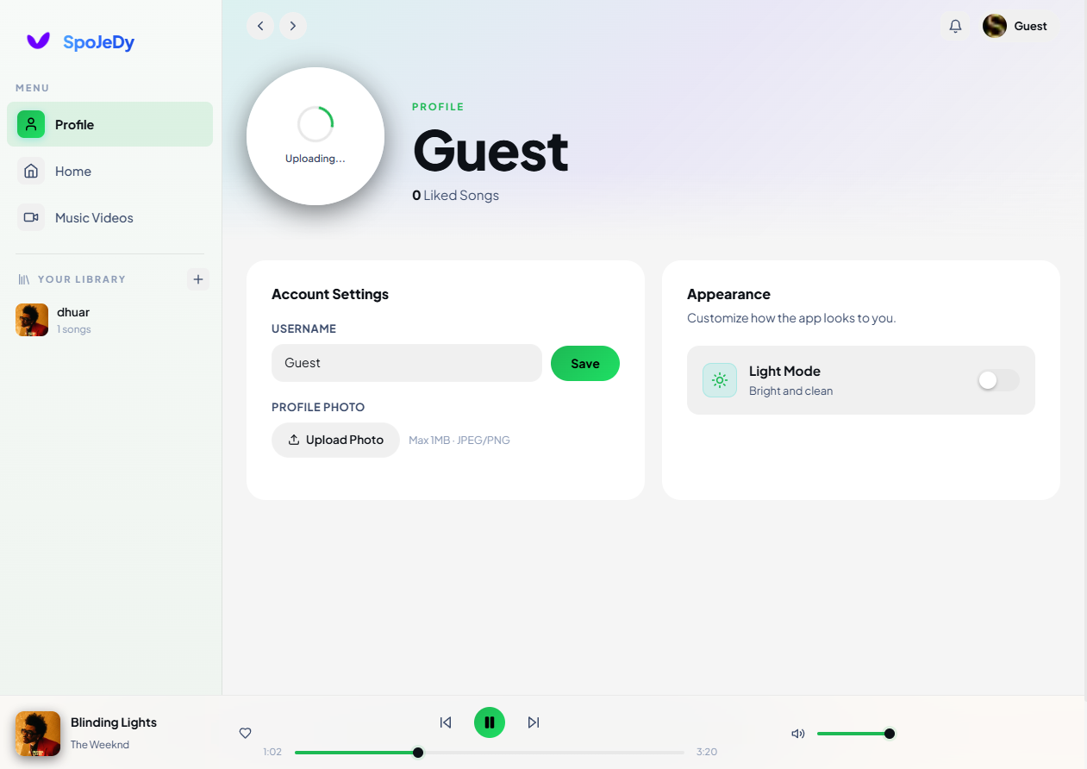
Features:
- Change username
- Upload profile image, there’s also progressive loading animation
- Change theme to light/dark mode

Playlist Page
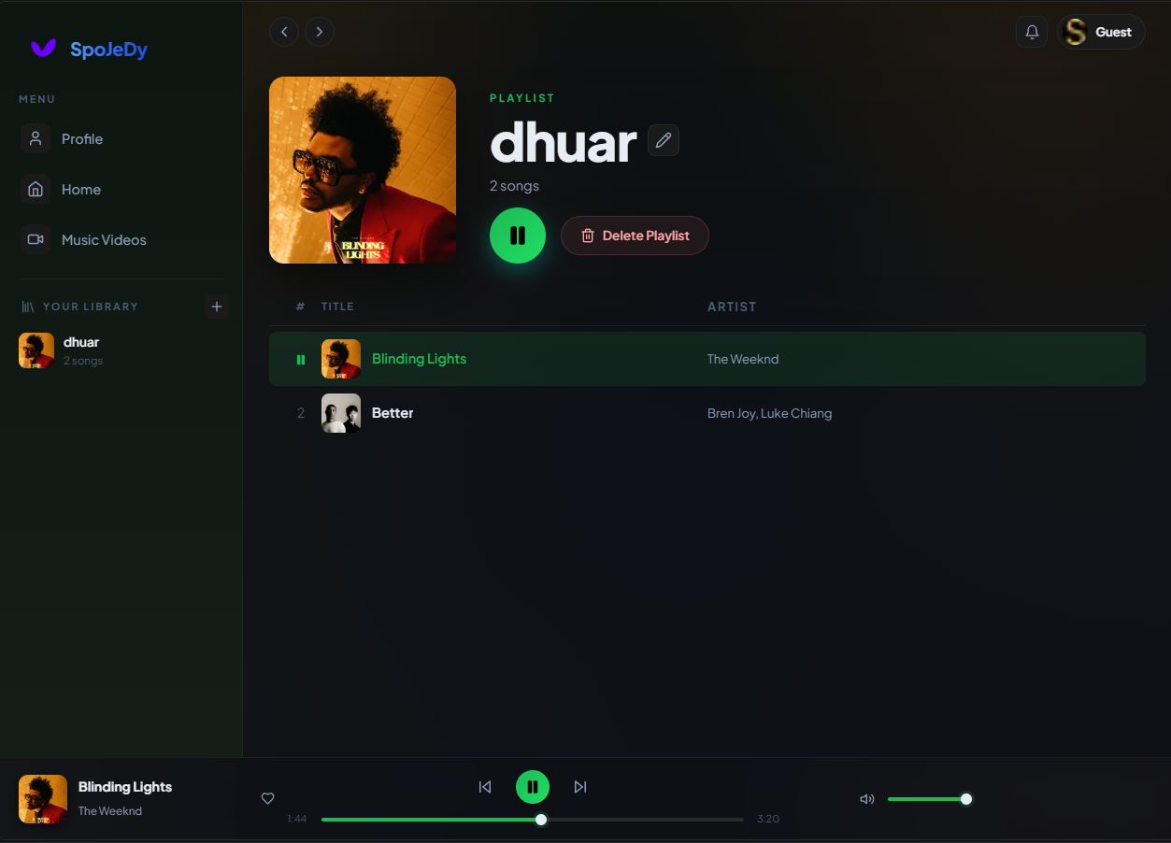
Features:
- Play songs in playlist
- Delete song in playlist
- Delete Playlist
- Change playlist name

